

**Bryn Derwen Newsletter**

**First Edition 2013**

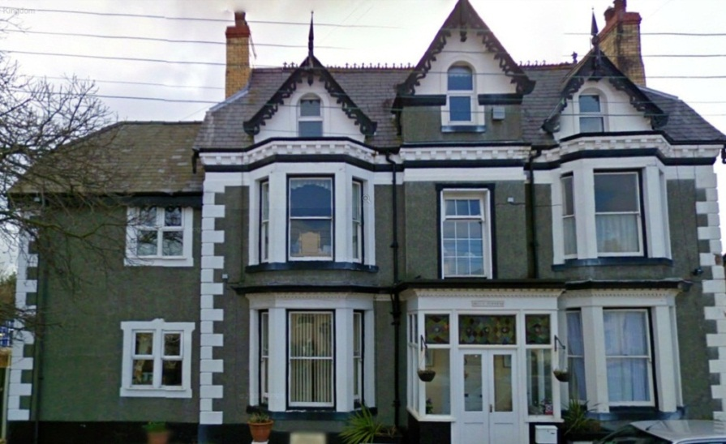

**Contact Details**

Bryn Derwen EMI Residential Home

Bryn Gobaith, St Asaph, Denbighshire

LL17 ODN

01745 582570

Email: [brynderwenhome@btinternet.com](mailto:brynderwenhome@btinternet.com)

Web: www.brynderwenhome.co.uk

**Condolences**

The staff and residents of Bryn Derwen would like to express their deepest sympathy for Ms Sheila Woodfine who sadly passed away this year. Sheila made many close friends during her time spent with us here and she will be deeply missed.

**About Us**

Bryn Derwen is a small EMI residential home in the historic city of St Asaph who specialise in caring for the elderly who have dementia. We are located in a quiet residential part of the city but are very close to all of the shops, post office and cathedral, and as such are very much part of the local community. We are registered with the Care Standards Inspectorate for Wales and we provide 24 hour care for 19 male and female long term care clients, as well as also providing care for our respite and day care service users. All of our bedrooms are spacious and have en-suite facilities.

The resident’s in Bryn Derwen receive professional care delivered with respect in a friendly, homely and compassionate environment, where quality of life is imperative. Our dementia care is provided by suitably qualified and dedicated teams in an environment personally adapted to each resident’s needs, all of whom receive a care plan which reflects their individual needs, interests, and physical and emotional abilities.

***Editors Message***

There have been many additions to Bryn Derwen over the past few months. As well as new staff members and animals to use in our pet therapy programme, we have also benefited from a fantastic garden makeover, a new minibus for day trips out, and an activities programme tailored to each resident’s needs and interests.

We have continued to work and build strong links within the community, and have also been able to undertake charity events to raise money towards the resident’s fund.

The staff at Bryn Derwen are committed to improving upon the high standards of professional care that we have to offer, and so as well as undertaking the on-going training opportunities provided by the company, we have also begun planning and organising a wide range of special activities and celebrations for our residents to enjoy over the coming months.

We sincerely hope that you will be able to join us and celebrate with us on these special occasions.

Thank you

*Helen Johnson (Activities Organiser)*

**Renovation & Transformations**

As stated earlier, Bryn Derwen has undergone many changes recently. As well as benefiting from being newly decorated to continue to provide a homely environment for our residents, we have also invested in improving upon our garden which now has enclosures for both our chickens and guinea pigs, a purpose built multi-sensory garden area, a water fountain and feature, new plants, flowers, shrubs and vegetables, and luxury outdoor benches for our residents and their families to enjoy.

As well as now being able to provide a comfortable environment for parties, walks, and quiet relaxation, our garden also enables our residents to take part in the up keep of their home by offering many different types of gardening activities.

**Some of our staff members**

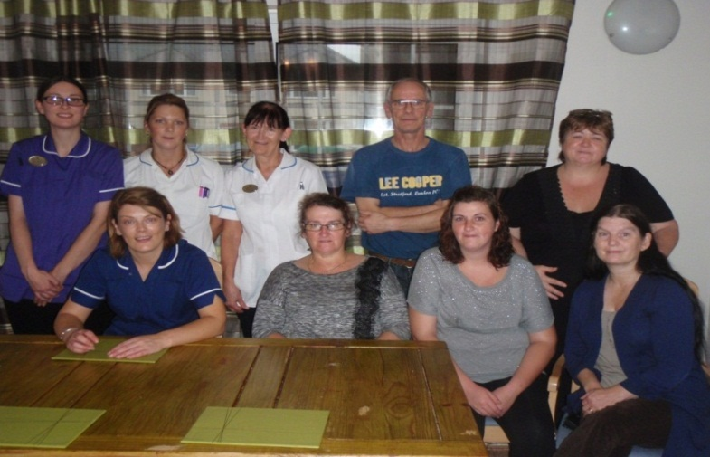

Our staff members are provided with on-going opportunities for learning and development to ensure that the care they give is not only the kindest possible, but that it is also delivered from a sound, professional knowledge base.

**Spending time with loved ones**

At Bryn Derwen we warmly welcome relatives to come and spend time with their loved ones, but we also understand how this can sometimes be difficult due to work commitments, travel issues, illness etc. This is why we also encourage both our residents and their relatives to keep in contact via phone calls and also through Skype. If anyone would like more information on the Skype service, please contact Margaret Spencer or Lina Davitt.

**Activities**

In Bryn Derwen we have actively placed our activities programme at the heart of our care service as we believe that they are essential to a person’s wellbeing as they give purpose and enjoyment to their day and so help to improve their quality of life. As well as helping the residents to feel valued, the activities programme we offer also assists them to maintain, maximise and encourage their skills, abilities and interests whilst also building up their confidence. The activities programme is tailored to the interests and abilities of each of our residents and is provided in both a group setting and individual basis, all of which promotes Bryn Derwens policy of maintaining independence, choice, rights, fulfilment, privacy, dignity and equal opportunities.

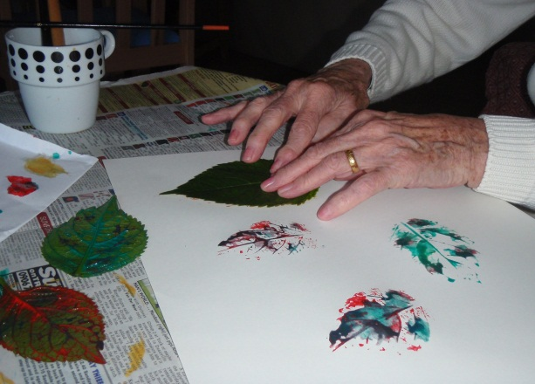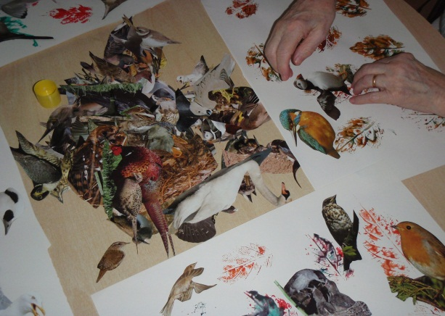

Our residents have the opportunity to participate in a wide range of activities amongst which are arts and crafts, gardening, baking, memory exercises, pet therapy, armchair exercises, dancing, quizzes, bingo, card games, board games, pampering sessions and multi-sensory activities. The multi-sensory approach is particularly useful for people with advanced dementia because bright colours, different sounds and textures can catch their attention in a way that other activities may not.

One of our most popular activities in this programme is our pet therapy sessions and here at Bryn Derwen we have a selection of animals which we use in this including chickens, dogs, guinea pigs and a budgie. Our residents take great enjoyment in helping to look after our pets and research literature indicates that controlled animal presence within a care setting can bring various benefits to residents including relaxation, reduced apathy and reduced agitation.

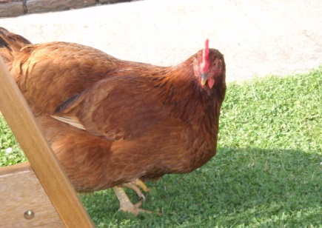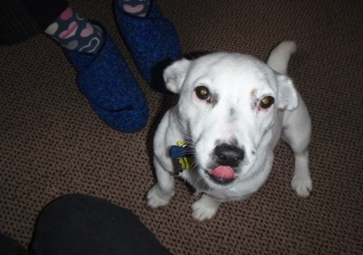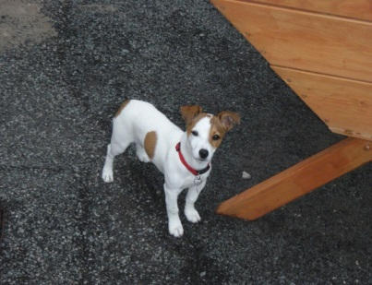

We recently acquired a minibus and our residents have the opportunity to go out on weekly trips to a variety of locations and scenic drives around North Wales. Our residents really enjoy and benefit from this service and have so far visited Llandudno and Ffrith beach, and will shortly be visiting Blackpool Illuminations.

As well as all this, Bryn Derwen also provides entertainers on a weekly basis and our residents thoroughly enjoy the performances from Tony Hudson, Gavin Strong, Christopher Dean, and John Broadhead.

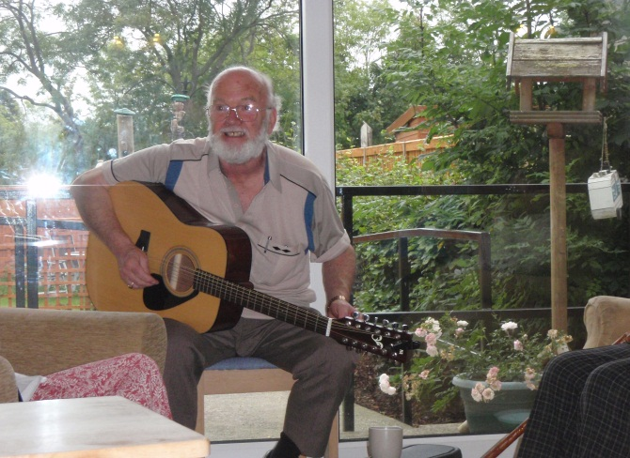

**Our friends in the community**

As well as our dedication and commitment to providing our residents with the highest quality of care and stimulation, another one of our main goals is to continue to build upon and develop new links within the community and over the last few months we have had a variety of visitors come to Bryn Derwen to spend quality time with our residents.

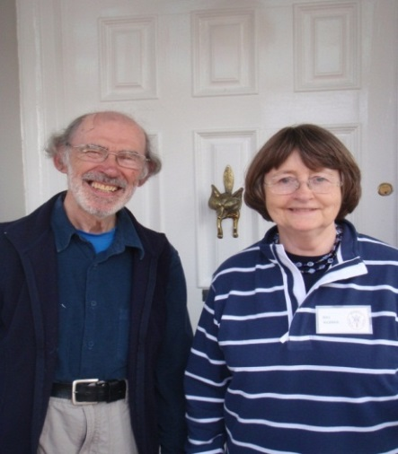

We would like to thank both Bev and Clive Webber of the St Asaph Archaeology Society who kindly came in to give a talk on their excavation work at Ysceifiog, as well as the children of St Asaph V.P. Infants School who visited and performed songs for us. The residents really enjoyed the mini concert and needless to say we are really looking forward to their next visit due over the Christmas season.

We are also regularly visited by Reverend Val and Reverend Elaine from St Asaph Cathedral who performs Church Service for us on the 1st Thursday of every month.

We will soon also be having regular visits from Age Concern who will be coming in to speak and work with our residents who were unfortunately affected by last year’s floods.

**Celebrations**

Over the last few months here at Bryn Derwen we have set up a variety of entertainment and activities to celebrate important events in the calendar. Here is a list of all the themed events that we have participated in.

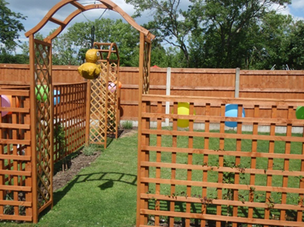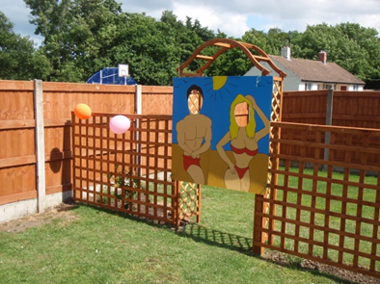

**Wimbledon**

During this important sporting event our residents were treated to strawberries and cream as well as a glass of champagne whilst they relaxed watching the finals of this tournament.

**St Asaph Scarecrow competition**

We really got into the spirit of this annual community event with our Michael Jackson scarecrow, and although we didn’t win a prize, we had lots of fun creating our entry into this competition.

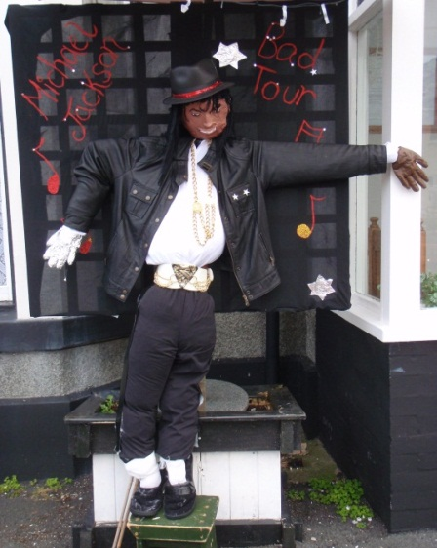

**Garden party**

After the renovation work was completed, the residents were treated to a garden party with an entertainer, a variety of organised activities, and a buffet. The residents really enjoyed listening to the singer and playing games such as bowling, Frisbee, pin the tail on the donkey, pass the parcel, piñata, and having their pictures taken with the seaside themed character boards. We were also able to raise some funds towards the residents fund through our name the chicken’s raffle, and we would like to once again thank everyone who participated in this event.

**Eisteddfod**

As St Asaph hosted this year’s Eisteddfod, we held our own celebrations by having a Welsh themed day in which we watched the Eisteddfod together, played traditional Welsh games, participated in traditional Welsh arts and crafts, and listened to poems by Dylan Thomas and hymns sung by Welsh choirs. As well as discussing the history of Wales and decorating Bryn Derwen with daffodils, leeks, flags, cuddly sheep and Welsh lady dolls, we were also treated to bara brith and leek soup.

**North Wales International Music Festival**

This music festival was held in St Asaph Cathedral and we were able to attend a saxophone and percussion concert entitled ‘Pasaos Duo’. The residents really enjoyed the wide variety of music performed as well as learning about the musical instruments used, and they were treated to tea and coffee once the concert ended.

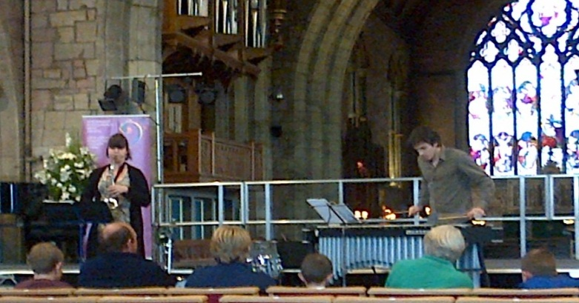

**Forthcoming Events**

The following are a list of dates that our weekly entertainment will be visiting and also dates for our organised parties. We would like to invite you all to come and join in with us on these special occasions.

Entertainers

* Wednesday 23/10/13 14.00-15.30 Christopher Dean
* Thursday 31/10/13 14.00-15.30 Tony Hudson
* Tuesday 5/11/13 15.30-17.00 Tony Hudson
* Wednesday 13/11/13 10.30-12.00 Gavin Strong
* Wednesday 20/11/13 14.00-15.30 John Broadhead
* Monday 25/11/13 14.00-15.30 Christopher Dean

Parties

* **Halloween** Thursday 31/10/13- entertainment, party games, fancy dress and decorations will all be provided for
* **Bonfire Night** Tuesday 5/11/13- there will be entertainment, party games and a fireworks display
* **Christmas Party** Wednesday 18/12/13- there will be entertainment, party games and a visit from Santa
* **New Year’s Party** Tuesday 7/1/14- entertainment and party games will be provided for

**Fundraising**

As many of you are already aware, we’ve been very busy fundraising to raise money towards the residents fund to help pay towards the costs for day trips out and parties. For our sponsored walk to Llyn Brenig we were able to raise £245 and we have also raised £28 so far on our new weekly lottery game. We are also hoping to raise money from our car boot sale which will be held on 26th October near Sainsbury’s. If anyone would like to donate any items or play our lottery then please could you speak to Helen Johnson (Activities Organiser).

We would once again like to take this opportunity to thank you all with your continued help and support.