

**Bryn Derwen Newsletter**

**Second Edition 2014**

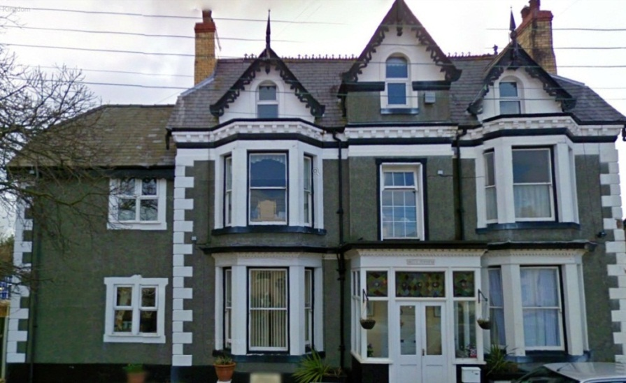

**Contact Details**

Bryn Derwen EMI Residential Home

Bryn Gobaith

St Asaph

Clwyd

LL17 ODN

01745 582570

Email: [brynderwenhome@btinternet.com](mailto:brynderwenhome@btinternet.com)

Web: brynderwenhome.co.uk

**About Us**

Bryn Derwen is a small EMI residential home in the historic city of St Asaph who specialise in caring for the elderly who have dementia. We are located in a quiet residential part of the city but are very close to all of the shops, post office and cathedral, and as such are very much part of the local community. We are registered with the Care Standards Inspectorate for Wales and we provide 24 hour care for 19 male and female long term care clients, as well as also providing care for our respite and day care service users. All of our bedrooms are spacious and have en-suite facilities.

The resident’s in Bryn Derwen receive professional care delivered with respect in a friendly, homely and compassionate environment, where quality of life is imperative. Our dementia care is provided by suitably qualified and dedicated teams in an environment personally adapted to each resident’s needs, all of whom receive a care plan which reflects their individual needs, interests, and physical and emotional abilities.

***Editors Message***

Welcome to the February edition of our newsletter!

We have been very busy over the last few months as we all made a special effort to celebrate Halloween, Christmas, New Year, and Chinese New Year, and we would like to thank everyone who took part.

We are already preparing for the summer by planning a wide range of themed parties and special day trips out, and we would like to invite you all to come and join us. As you can imagine, we are all looking forward to having some warmer weather so that we can visit the seaside, have picnics together, and once again enjoy ourselves and relax in our purpose built multi-sensory garden.

I hope you enjoy all of our latest news!

*Thank you*

***Helen Johnson (Activities Organiser)***

**New Staff Members**

We are pleased to welcome three new staff members here at Bryn Derwen.

Steve Davitt is our new Driver, and Beck Mariott is our new Activities Assistant. All have already made fantastic contributions to our home and have already become valuable members of our team.

**Spending time with loved ones**

At Bryn Derwen we warmly welcome relatives to come and spend time with their loved ones, but we also understand how this can sometimes be difficult due to work commitments, travel issues, illness etc. This is why we also encourage both our residents and their relatives to keep in contact via telephone and also through Skype. If anyone would like more information on the Skype service, please contact Margaret Spencer or Lina Davitt.

**Activities**

We have a wide variety of activities here at Bryn Derwen as we believe that they are essential to a person’s wellbeing as they give purpose and enjoyment to their day and so help to improve their quality of life.

We enjoy music therapy sessions, arts and crafts, gardening, baking, memory exercises, armchair exercises, dancing, sing a longs, quizzes, bingo, card games, board games, pampering sessions, multi-sensory activities and pet therapy.

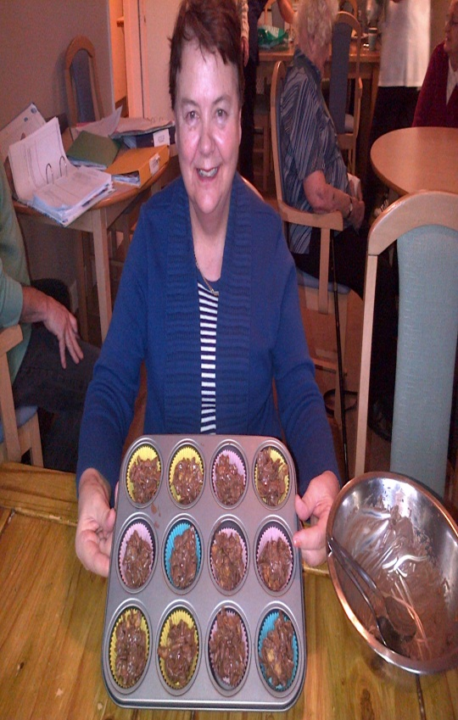 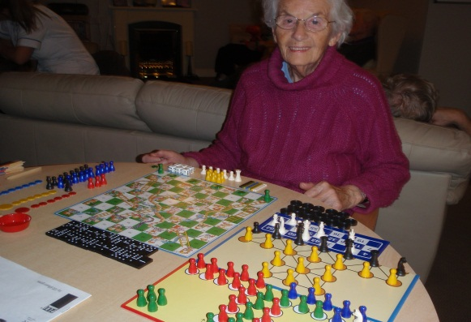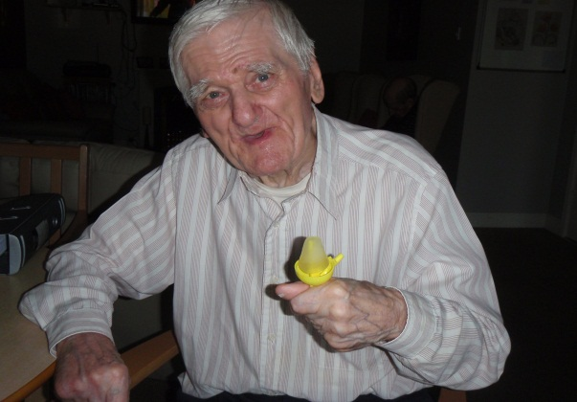

As pet therapy is one of our most popular activities with our residents, we are pleased to inform you that we have new additions to our pet therapy programme. Our guinea pigs have reproduced and now we have nine guinea pigs in total.

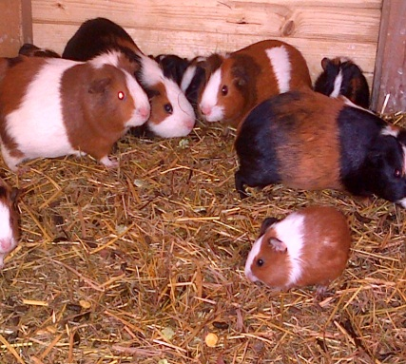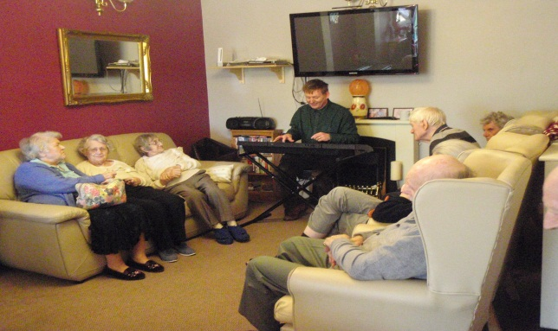

We are also able to offer our residents the opportunity to participate in the organised day trips and to visit places like Llandudno, Rhyl, Conway, and Rhos on Sea. We were even fortunate enough to visit Blackpool Illuminations over the festive period.

Bryn Derwen also provides entertainers on a fortnightly basis and our residents thoroughly enjoy the performances from Tony Hudson, Gavin Strong, Christopher Dean, and John Broadhead.

**Our friends in the community**

As well as our dedication and commitment to provide the highest quality of care and stimulation, we also continue to build upon and develop new links within the community. Over the last few months we have had a variety of community visitors spending quality time with our residents.

We would like to thank the children and staff from both St Asaph V.P. Infants School and Ysgol Esgob Morgan who kindly came in to perform Christmas carols for us. We also extend out thank Reverend Val and her friends Tom and Carol who performed a Christmas themed church service retelling the nativity story complete with traditional Christmas carols.

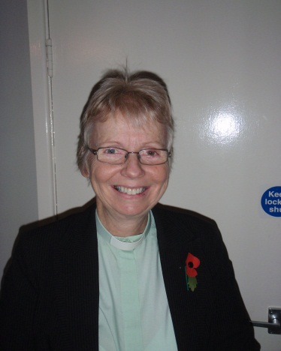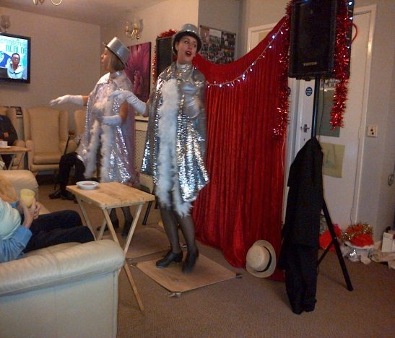

All of these performances were really enjoyed by our residents and it helped us all to get into the Christmas spirit.

Reverend Val and Reverend Elaine from St Asaph Cathedral are both regular visitors here at Bryn Derwen, as they perform Church Service for us on the 1st Thursday of every month.

Our thanks also go to Pat MacKenzie and her volunteers from Age Concern who came to visit and work alongside our residents who were unfortunately affected by the floods back in 2012.

We would also like to take this opportunity to thank the Health and Social Care students from both Llandrillo College and Deeside College who came to work with us on their placements. We hope that they all go on to have successful careers within the care industry.

**Celebrations**

Over the last few months here at Bryn Derwen we have set up a variety of entertainment and activities to celebrate important events in the calendar. Here is a list of all the themed events that we have participated in.

**Halloween**

We celebrated Halloween in style last year by decorating our home with cobwebs, spiders, bats, balloons, skeletons and pumpkins, as well as also hosting an extravagant party complete with a buffet, entertainer and Halloween themed activities.

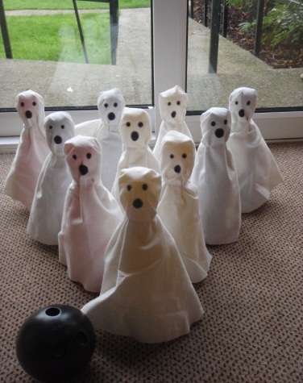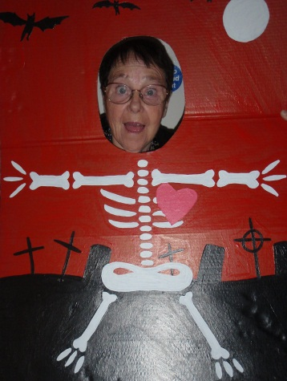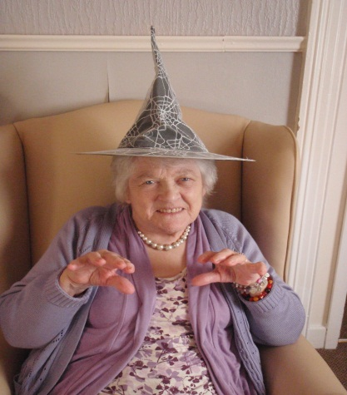

The activities consisted of Trick or Treating games, pass the creepy parcel, boo bowling, pumpkin piñata, and pin the tail on the black cat.

Our staff members also got into the ‘spirit’ of things by taking part in a fancy dress competition, and all the residents, guests and staff had a frighteningly fantastic time.

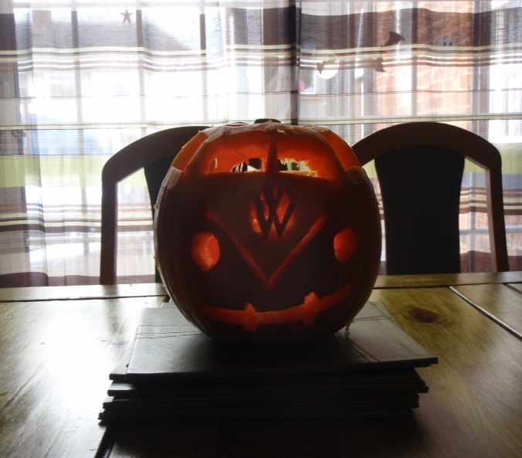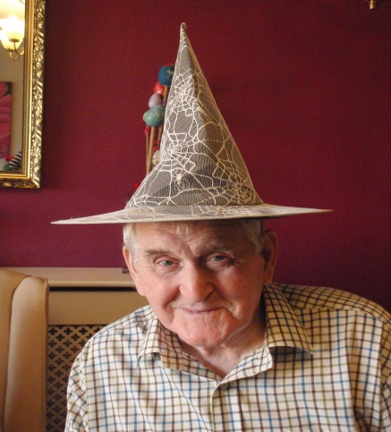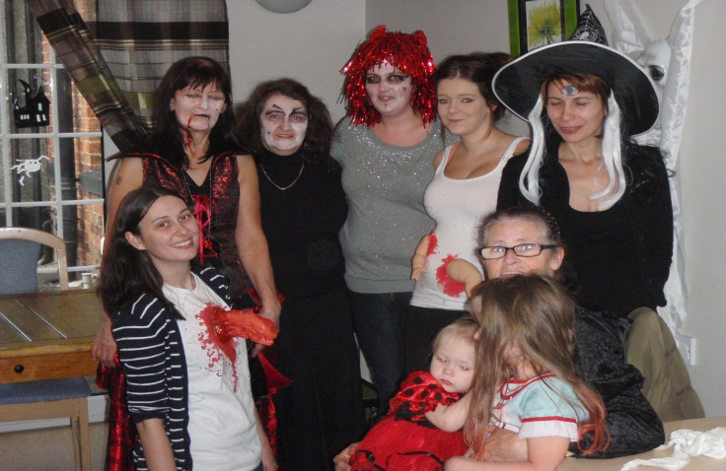

**Christmas**

We had an extremely busy December here at Bryn Derwen as we planned and prepared for all of our Christmas events and activities.

After staff had placed both traditional Christmas decorations and items made during our arts and crafts sessions around the home, the residents then took to decorating the Christmas tree themselves, as well as making Christmas cards for their loved ones.

As well as being treated to a trip to Blackpool to see the Illuminations, we were also fortunate enough to have raised enough money to have a Christmas meal at The Kings Head in Rhuddlan, both of which proved hugely popular with our residents.

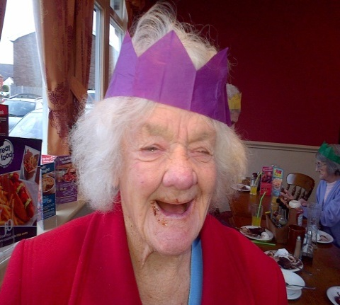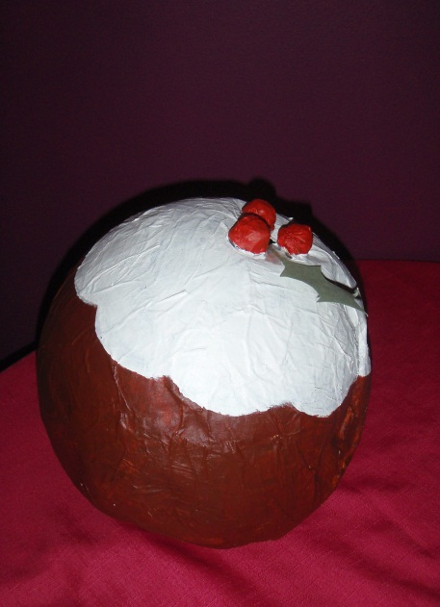

We were also extremely fond of the Christmas carol services performed by Ysgol Esgob Morgan, St Asaph V.P. Infants School, Reverend Val and her friends, and our regular entertainers; all of whom kindly came to visit us at different times throughout the festive period.

We also held a Christmas party where we played a variety of festive games and Christmas themed quizzes, sang carols together, and took turns on the karaoke machine. As well as this we also had a Christmas pudding piñata, pin the nose on Rudolph, and watched a home movie we had made of ourselves discussing what we enjoy most about Christmas and reminiscing as to what was the best ever present we had received.

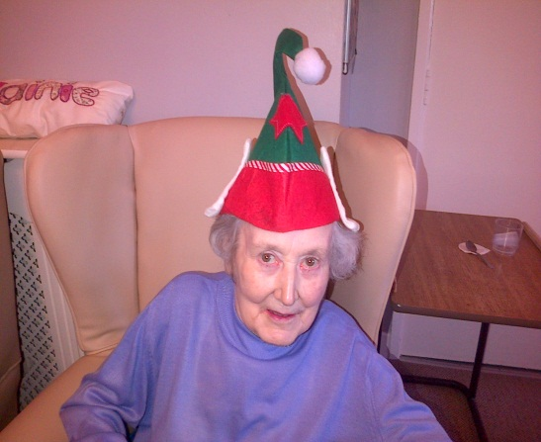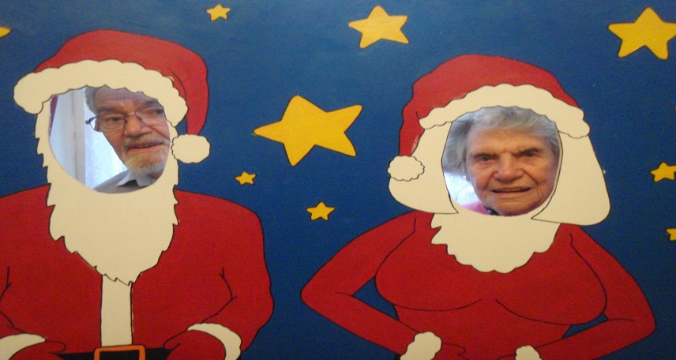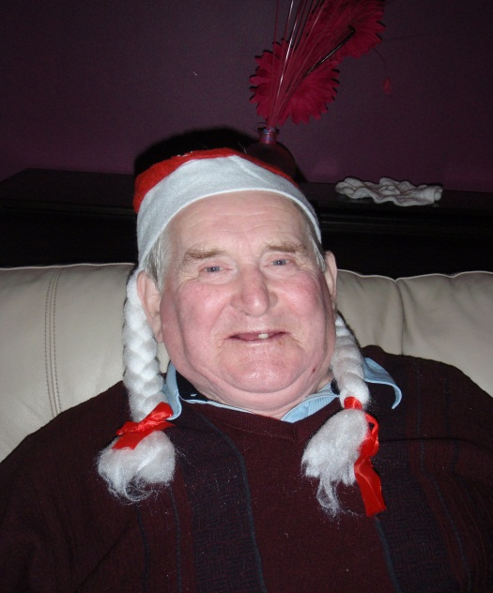

Once again, the staff of Bryn Derwen joined in with the celebrations by holding a fancy dress competition, and congratulations go to both Suzanne Foulkes and Tracey Ogden for their winning ‘Salt and Pepper’ costumes.

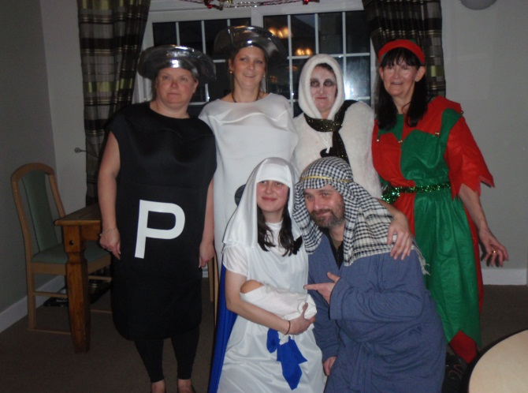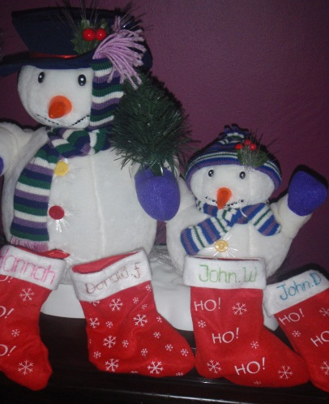

As it is the season of giving, all of our residents were each handed their own personalised Christmas stocking at the end of the party, and we would once again like to thank everyone who has contributed to our fundraising events, as this wouldn’t have been possible to do without your help.

**New Year**

After all of our Christmas celebrations we decided to celebrate the New Year in a more quiet manner and so simply had an entertainer come and sing for us as we discussed amongst ourselves our New Year’s resolutions as well as all the things we hope 2014 brings.

**Chinese New Year**

The 31st of January marked Chinese New Year and we had lots of fun celebrating the year of the horse.

After decorating our home and having a brief history lesson, we then learnt about the Chinese Zodiac and we were surprised to find that several of our residents were born in the year of the horse themselves.

We spent the day listening to Chinese music, having a quiz on China, doing calligraphy, and discovering what the future holds for us by using Chinese Fortune Sticks.

The ladies in particular enjoyed learning about ‘The Language of the Fan’ as we used only our Chinese fan and some simple hand gestures to communicate to others without words.

We finished our celebrations by eating some traditional Chinese foods and we all decided that we would like to sample more exotic foods in the future.

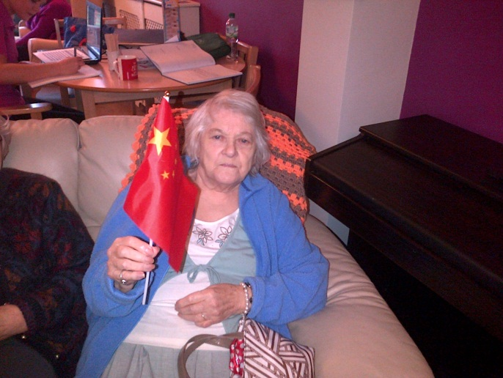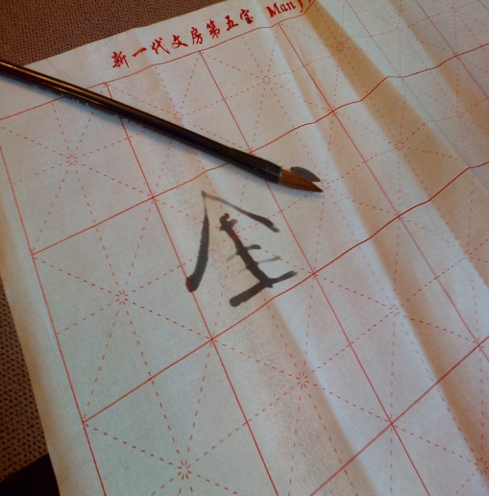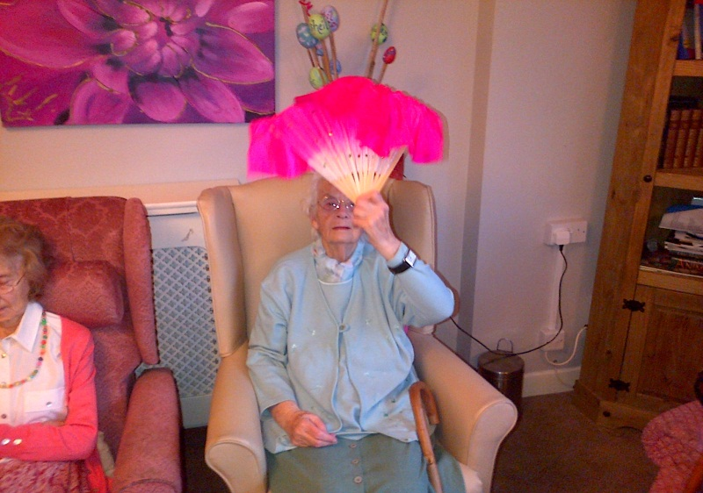

**Forthcoming Events**

The following are a list of dates that our weekly entertainment will be visiting and also dates for our organised parties. We would like to invite you all to come and join in with us on these special occasions.

Entertainers

* Wednesday 19/02/14 @ 10.30-12.00
* Wednesday 05/03/14 @ 10.30-12.00
* Wednesday 19/03/14 @ 10.30-12.00
* Wednesday 02/04/14 @ 10.30-12.00
* Wednesday 16/04/14 @ 10.30-12.00
* Wednesday 30/04/14 @ 10.30-12.00
* Wednesday 14/05/14 @ 10.30-12.00
* Wednesday 28/05/14 @ 10.30-12.00
* Wednesday 11/06/14 @ 10.30-12.00
* Wednesday 250/6/14 @ 10.30-12.00

Parties*

* **Valentine’s Day** Friday 14/02/14- entertainment, party games, and decorations will all be provided for
* **Fashion Show** Friday 21/02/14- there will be entertainment, party games and a catwalk area for all our models
* **St David’s Day** Friday 28/02/14- there will be Welsh entertainment and Welsh themed activities for us all to enjoy
* **Pancake Day** Tuesday 4/03/14- we will be spending the day enjoying homemade pancakes together and competing in our sponsored pancake race
* **St Patrick’s Day** Monday 17/03/14- we will have a variety of Irish themed activities for us all to enjoy
* **Mother’s Day** Friday 28/03/14- we will be making cards and decorating our home with flowers in order to get ready for Mothering Sunday
* **Easter** Thursday 17/04/14- we have a variety of activities planned to celebrate Easter together including an egg hunt
* **St George’s Day** Wednesday 23/04/14- we have a really fun day planned with a variety of patriotic activities for everyone to join in with
* **Father’s Day** Friday 13/06/14
* **Summer Garden Party** Thursday 19/06/14- we have already started planning ways to make this year’s summer party even bigger and better than last years!

*Some of the days we have our parties may be slightly out of synchronisation with the actual day (e.g. St. David’s day is on 1st March) due to falling on a weekend when our Activities’ organiser is not working.

**Fundraising**

As many of you are already aware, we’ve been very busy fundraising to raise money towards the residents fund to help pay towards the costs for day trips out and parties. We have raised money from our weekly lottery game and we were also able to raise money from our car boot sale thanks to your kind donations.

We are also planning to go on our annual sponsored walk to Llyn Brenig as well as having a sponsored pancake race against a few other care homes in early March.

If anyone would like to play our lottery or sponsor any of our fundraising events then please could you speak to Helen Johnson (Activities Organiser).

We would once again like to take this opportunity to thank you all with your continued help and support.

**Other News**

**Congratulations**

We would like to congratulate Amy Jones on the arrival of her son Max who was born on the 11th September weighing 5 pounds and 12.5 ounces.

Congratulations also go to Jade Roberts on the birth of her son Cai who was born on the 29th January weighing 7 pounds and 6 ounces.

**Condolences**

The staff and residents of Bryn Derwen would like to express their deepest sympathies for Mr Leslie McCurdy and Mrs Helen Rennell both of whom sadly passed away last year.