

**Bryn Derwen Newsletter**

**Third Edition 2014**

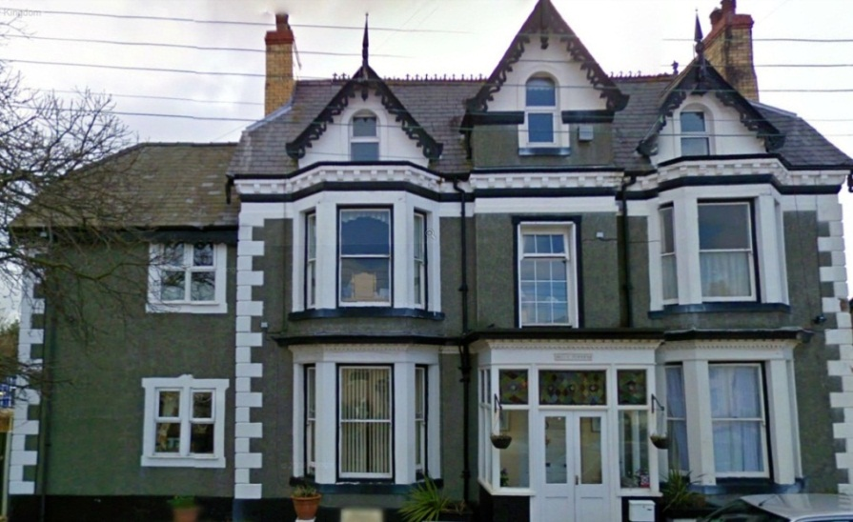

**Contact Details**

Bryn Derwen EMI Residential Home

Bryn Gobaith

St Asaph

Denbighshire

LL17 0DN

01745 582570

Email: [brynderwenhome@btinternet.com](mailto:brynderwenhome@btinternet.com)

Web: brynderwenhome.co.uk

**About Us**

Bryn Derwen is a homely EMI residential care home in the historic city of St. Asaph. We are situated in a quiet location just off Mount Road next to open fields yet minutes from shops, post office and the Cathedral. Bryn Derwen is registered with the Care Standards Inspectorate for Wales for nineteen ladies and gentlemen residents and provide care for the physical, emotional and psychological needs for the elderly with dementia.

We also provide care for our respite and day care service users. All of our bedrooms are spacious and have en-suite facilities. The resident’s in Bryn Derwen receive professional care delivered with respect in a friendly, homely and compassionate environment, where quality of life is imperative. Our dementia care is provided by suitably trained dedicated teams in an environment personally adapted to each resident’s needs, all of whom receive a care plan which reflects their individual needs, interests, and physical and emotional abilities.

**Editors Message**

Hello everyone and welcome to the May edition of our newsletter!

Our calendar has been very full during the last few months as there have been a lot to celebrate, and we have more events planned for the summer season too.

With so many positive things happening in our home, we have devoted this newsletter to our most recent charity events and work with our friends in the community. This will enable us to reflect on our achievements, none of which would be possible without your continuing help and support.

I hope you enjoy all of our latest news!

Thank you

Helen Johnson (Activities Organiser)

**New Staff Members**

We are pleased to welcome two new staff members here at Bryn Derwen.

Rachel Doherty has joined our team of Care Assistants and Jo Cupit is our new Cook. We hope they will settle well and will enjoy their new roles.

**Spending time with loved ones**

At Bryn Derwen we warmly welcome relatives to come and spend time with their loved ones, but we also understand how this can sometimes be difficult due to work commitments, travel issues, illness etc. This is why we also encourage both our residents and their relatives to keep in contact via phone calls and also through Skype. If anyone would like more information on the Skype service, please contact Margaret Spencer or Lina Davitt.

**Activities**

We have a wide variety of activities here at Bryn Derwen as we believe that they are essential to a person’s wellbeing as they give purpose and enjoyment to their day and so help to improve their quality of life.

We enjoy music therapy sessions, arts and crafts, gardening, baking, memory exercises, armchair exercises, dancing, sing a longs, quizzes, bingo, card games, board games, pampering sessions, multi-sensory activities and pet therapy.

Our pet therapy programme continues to be very popular with our residents, and we were fortunate enough recently to benefit from having Paul the Cockerel visit us and our hens. As the guinea pigs continue to grow, we are pleased to inform you that five of them have been

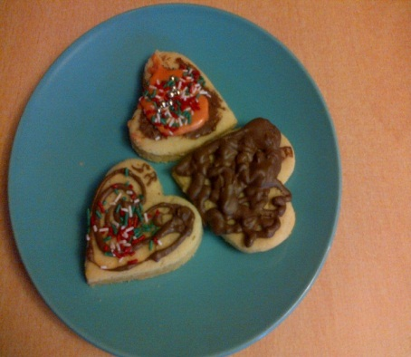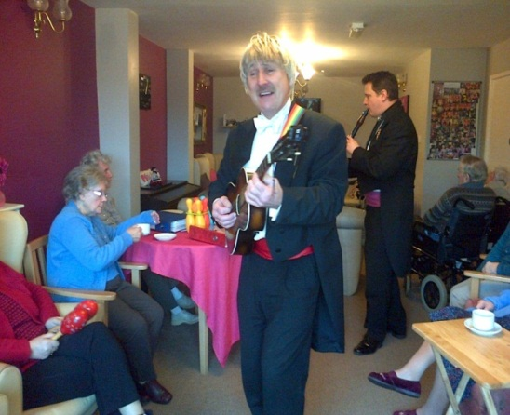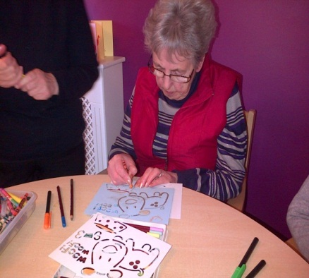

lovingly re-homed with some of our staff members. We would also like to take this opportunity to thank our friends from The Grange for donating their hutch, run, food and bedding for use in our pet therapy programme.

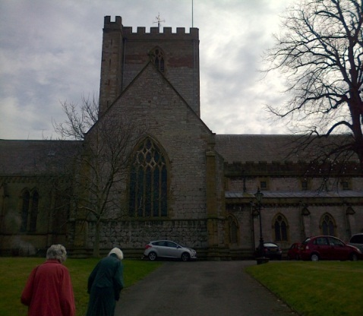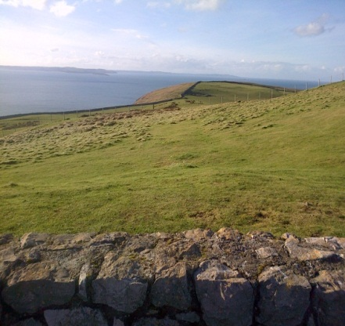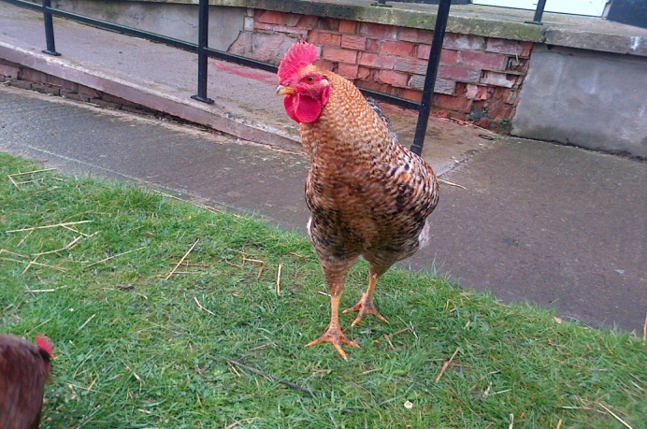

We are also able to offer our residents the opportunity for day trips out to see the countryside and local attractions and so are regularly able to visit places like Llandudno, Rhyl, Conway, and Rhos on Sea, and we were even fortunate enough recently to visit the Tweedmill for a shopping trip and afternoon tea party.

As well as all this, Bryn Derwen also provides entertainers on a fortnightly basis and our residents thoroughly enjoy the performances from Tony Hudson, Gavin Strong, Christopher Dean, and John Broadhead.

**Our friends in the community**

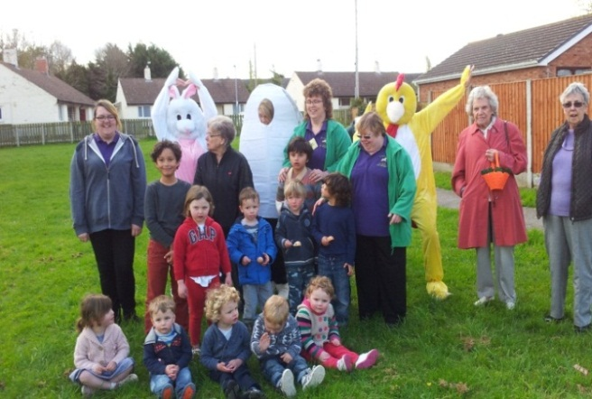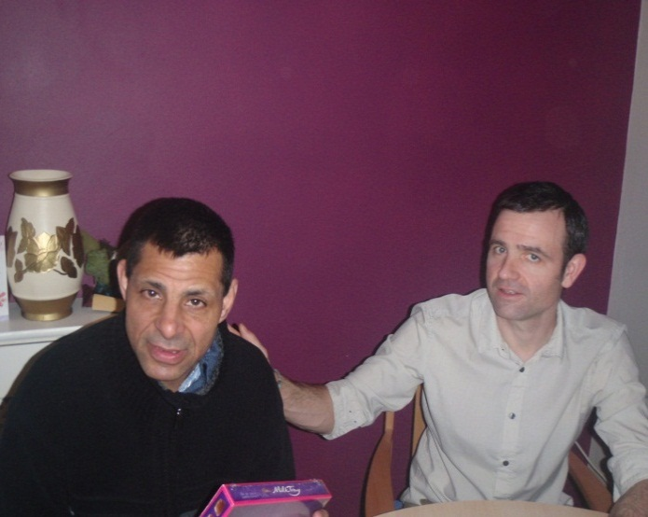

We have excellent relationships with our friends in the community and they regularly support the activity programme, themed parties, and charity events that we run, and we would like to thank everyone who participated in our sponsored pancake race and Easter celebrations.

We would also like to take this opportunity to thank the Health and Social Care students from Llandrillo College who came to work with us on their placements, and we hope that they all go on to have successful careers within the care industry.

In addition we are pleased to announce that our friends from Age Concern will be returning soon to run a confidence course for our residents called ‘Speak Up’, and we look forward to working with them again.

**Celebrations**

Over the last few months here at Bryn Derwen we have set up a variety of entertainment and activities to celebrate important events in the calendar. Please see the list of all the themed events that we have organised and participated in:

**Valentine’s Day**

We were very lucky to be given a special romantic music concert on Valentine’s Day, courtesy of Music in Hospitals, and all of our residents really enjoyed listening to their favourite love songs.

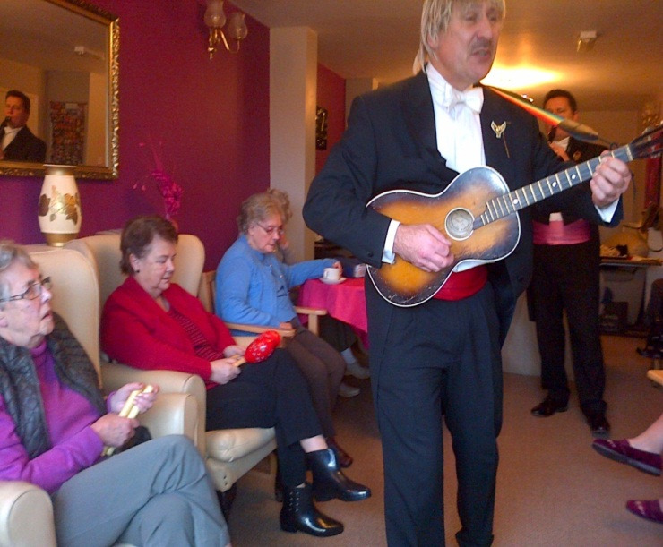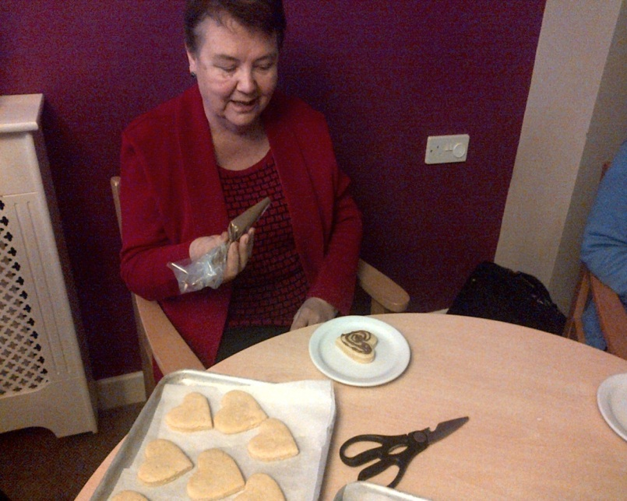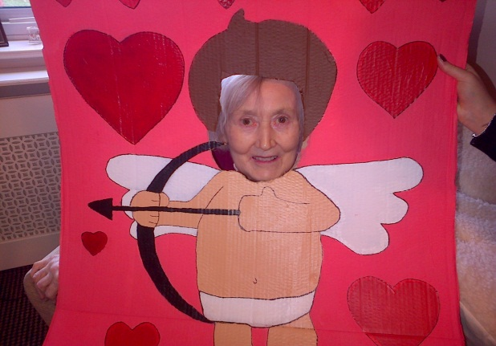

For the rest of the day we enjoyed watching romantic films together and decorating our heart shaped biscuits for us all to share.

**Bird Feeding Month**

As February is Bird Feeding Month we spent time learning about all the different birds that visit our garden and all the different types of bird songs.

We also made a large batch of fat balls together to place in our multi-sensory garden to help entice even more birds to come and visit us.

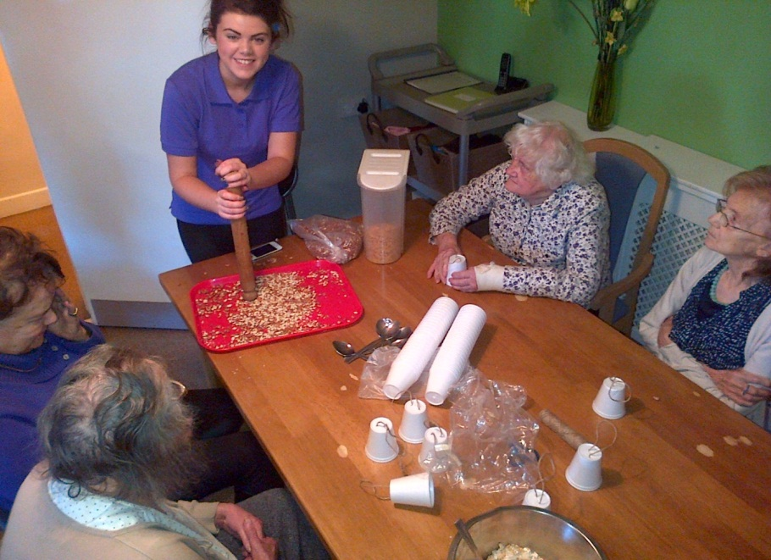

**Fashion Show**

As part of our continuous investment in our Activity Programme, our Activities Assistant Beck Mariott organised a fashion show for all of our residents and staff to enjoy.

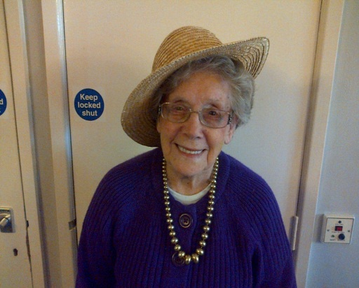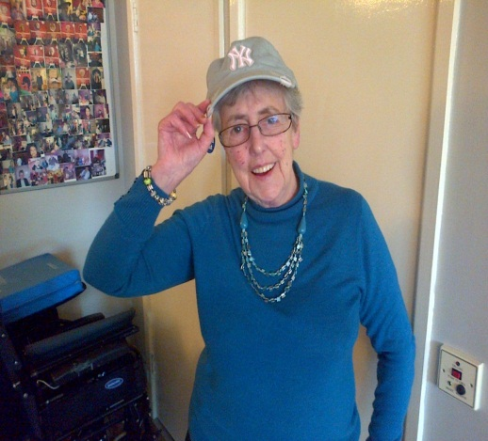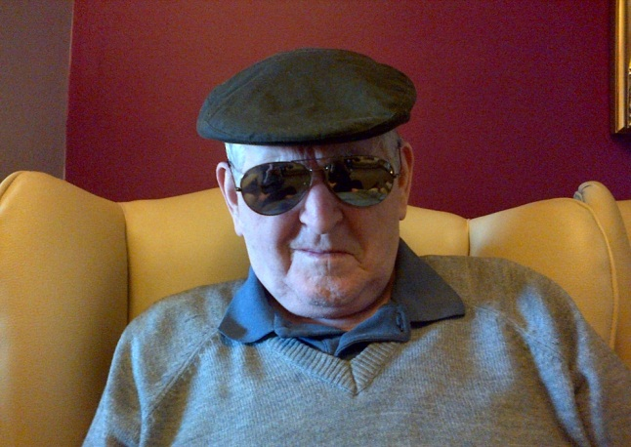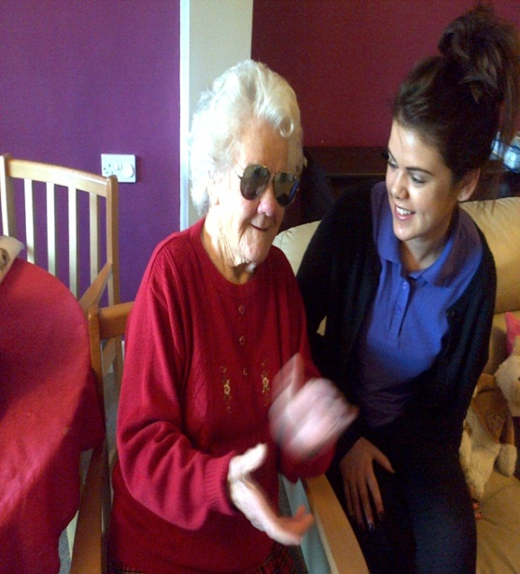

The residents spent the afternoon having their hair, nails, and make up done. Later they had the opportunity to choose and use perfumes, aftershaves, and fashion accessories and pose for the camera as well as participating to the catwalk to show everyone their new look.

All of our models looked fabulous and congratulations go to Hannah Evans who won Best Model category and received some luxurious chocolate as a prize.

**St David’s Day**

We had lots of fun preparing for and celebrating the most important date in the Welsh calendar.

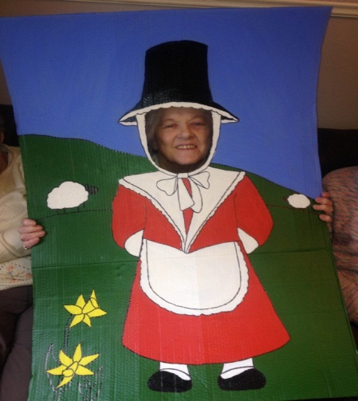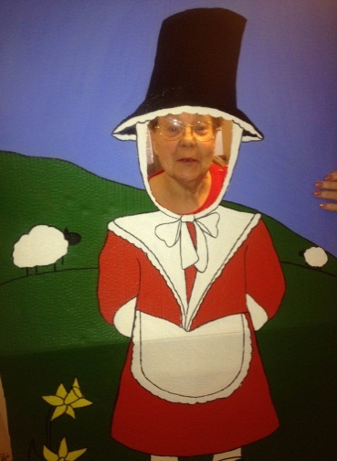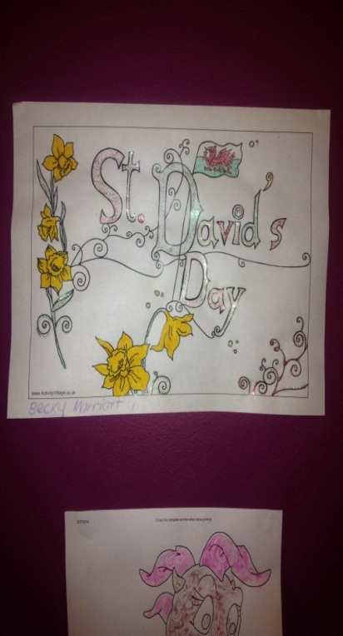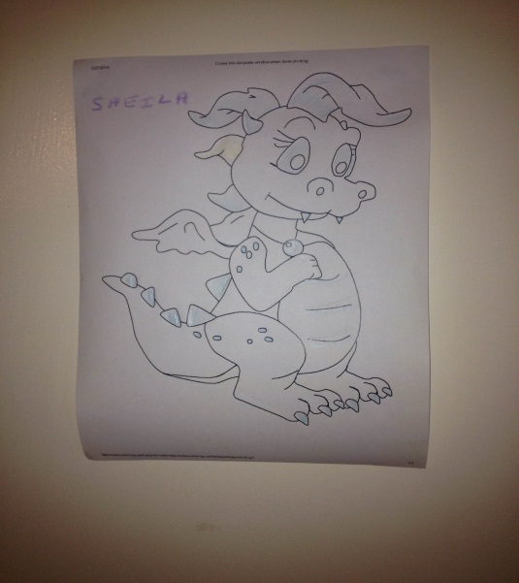

After decorating our home with Welsh flags, patriotic coloured balloons, newly cut daffodils, and traditional Welsh art and craft items, our residents were given a brief history on Wales as well as some Welsh language lessons run by our Activities Assistant Sarah McNamara.

We finished our celebrations by listening to traditional Welsh songs and watching Welsh films such as ‘How Green was my Valley’.

**Pancake Day**

We celebrated Shrove Tuesday by treating all of our residents and visiting guests to some delicious pancakes, as well as holding a special charity event for the day.

We would like to thank all of the staff and residents from The Grange and Phoenix House Care Home who kindly came to participate in our sponsored pancake race. We all had a wonderful time making new friends and we raised £43 for our Residents Fund.

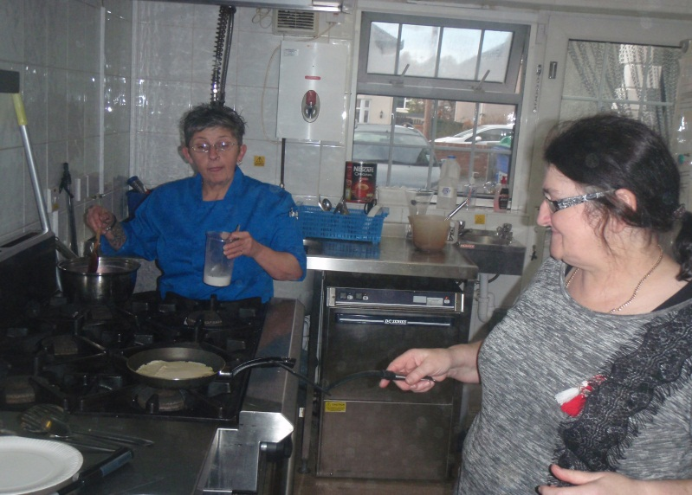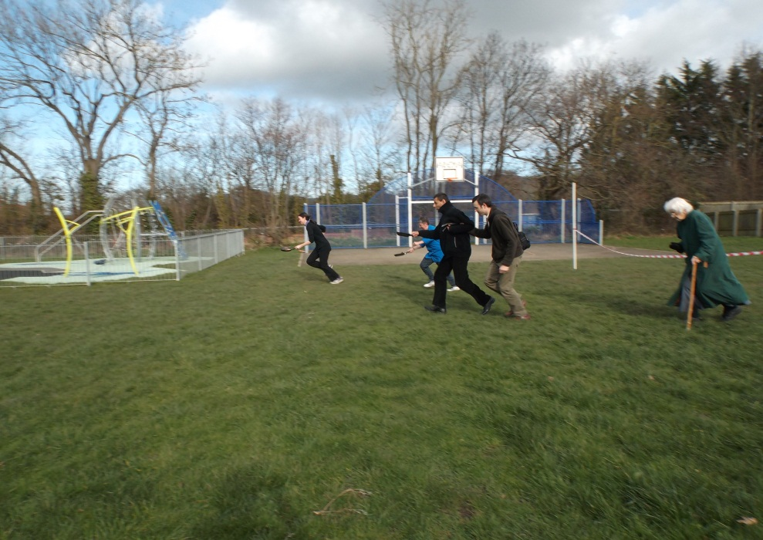

**World Book Day**

In keeping with the World Book Day tradition, we spent the day reading a collection of short stories together as well as reminiscing over some of our favourite childhood books.

**Hymnathon at the Cathedral**

To support our friends at St Asaph Cathedral, we went along to watch the Cathedral choir on Saturday 15th May as they sang 107 hymns as a charity event.

We really enjoyed the performance and we were pleased to hear that they raised £1200 to put towards the Cathedral’s renovation fund.

**St Patrick’s Day**

We celebrated St Patrick’s Day this year by decorating our home with balloons and Irish themed art and craft items that we had made.

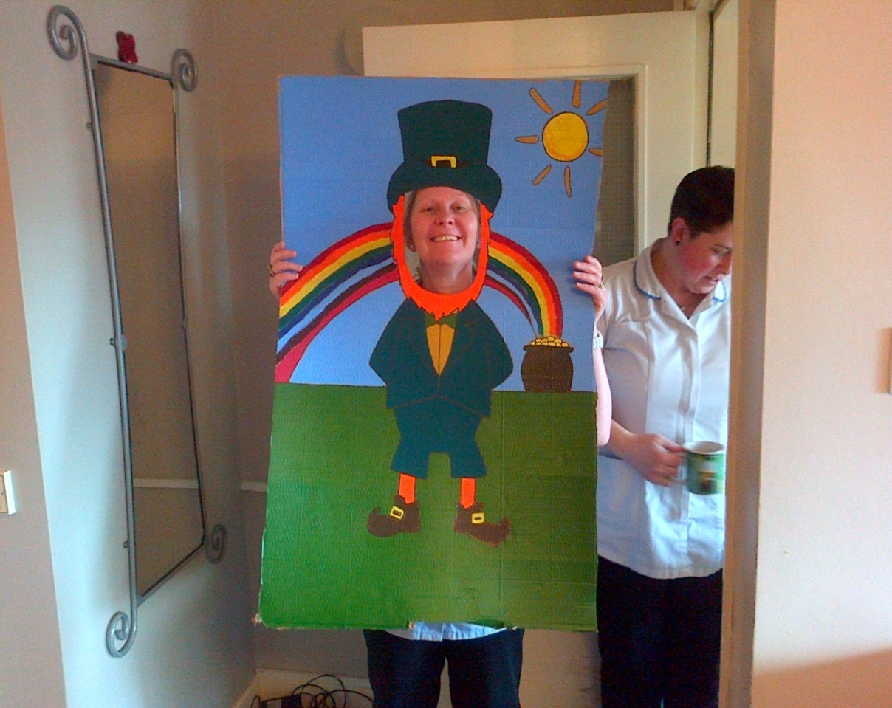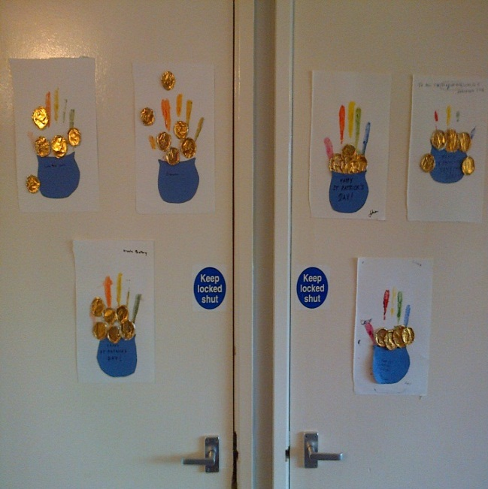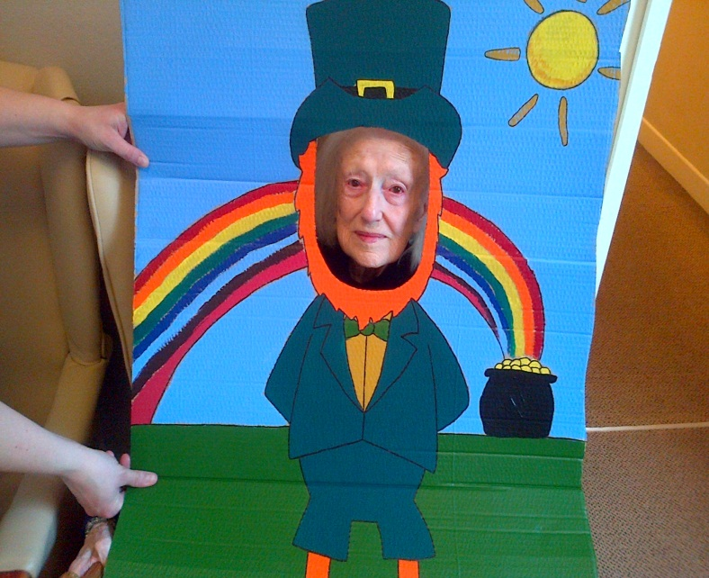

We then had a quiz on Ireland whilst listening to traditional Irish songs, and then watched a Riverdance dvd as well as an episode of Father Ted.

After dinner the residents took part in a treasure hunt and after finding gold chocolate coins, they were then treated to some Guinness and Irish coffee.

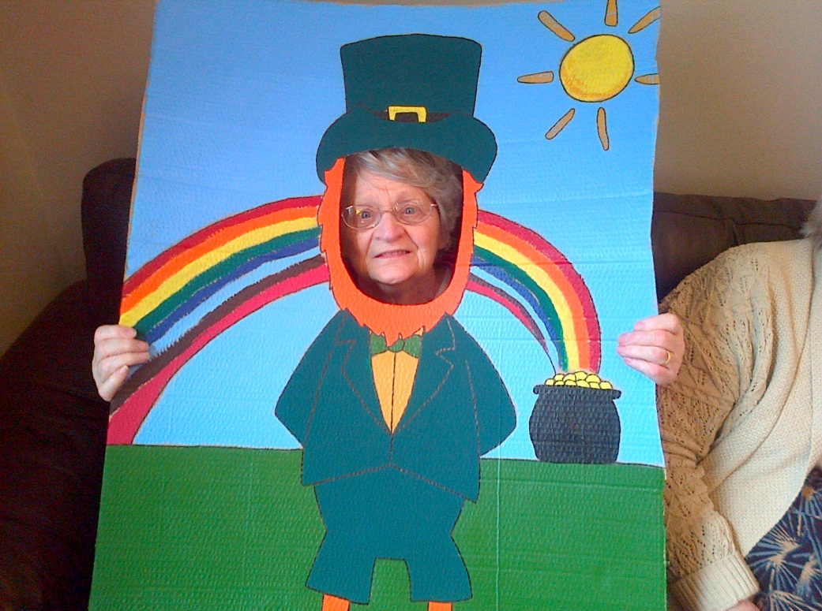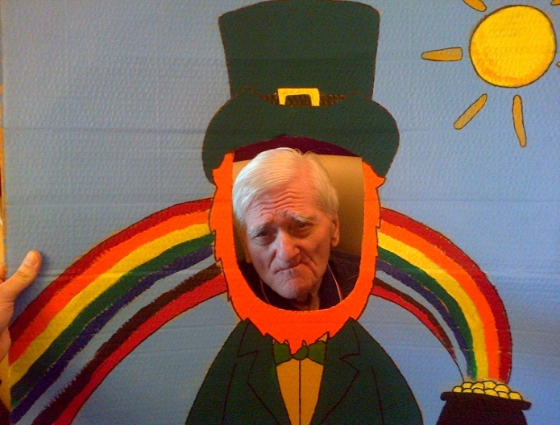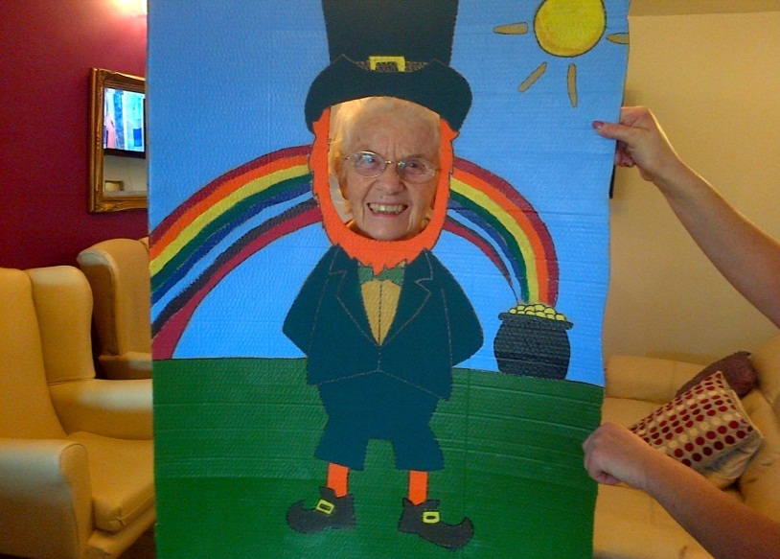

**Tweedmill Tea Party**

The staff and residents of Bryn Derwen would like to sincerely thank the family of Mrs Betty Burns-Jones who very kindly organised and funded a day trip for them to the Tweedmill shopping outlet for tea, coffee and cakes. Needless to say, all of our ladies thoroughly enjoyed this treat as well as the chance to go and do some shopping.

**Mother’s Day**

A few days before Mothering Sunday, we were busy decorating our entire home with balloons and flowers for this special day, and we also bought some chocolate treats for everyone to enjoy together.

The ladies enjoyed receiving all of the flowers, cards, and gifts that their loved ones had bought for them, and due to the amount of flowers received we actually ran out of vases! Fortunately our Care Assistants solved this problem by improvising with other items, and so helped the day go on to be a success!

**Easter**

We were very busy during April as we planned and prepared for all of our Easter events and activities.

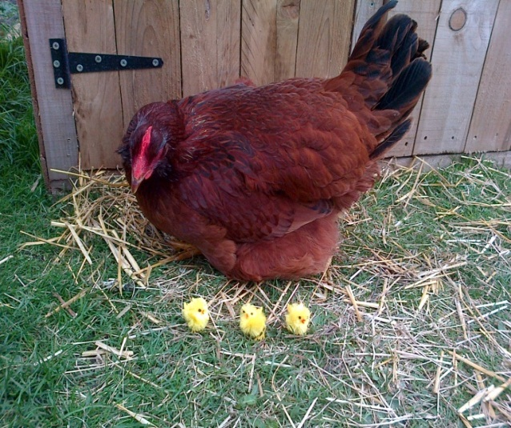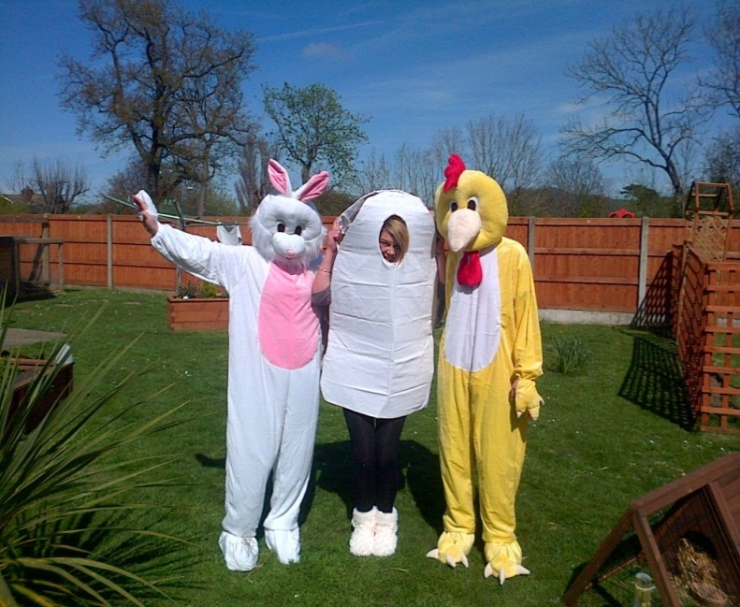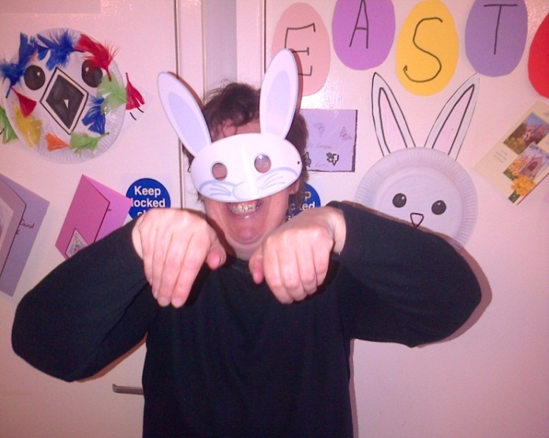

After decorating our home with Easter themed artworks that we had made, the residents then made Easter cards for their loved ones. We then spent the rest of the afternoon taking part in an Easter themed quiz and told each other Easter jokes.

On the actual day of our Easter party, we had our friends from The Grange, Bronafallen Care Home and Sugar Dandy’s Nursery, as well as our Easter Olympic mascots Mo Rabbit, Jessica Eggis, and Chickain Bolt come visit us and take part in our Easter egg hunt and egg and spoon race. Even though the rabbit blatantly cheated, everyone really enjoyed taking part in the events and sweets and chocolates were handed out to everyone who attended.

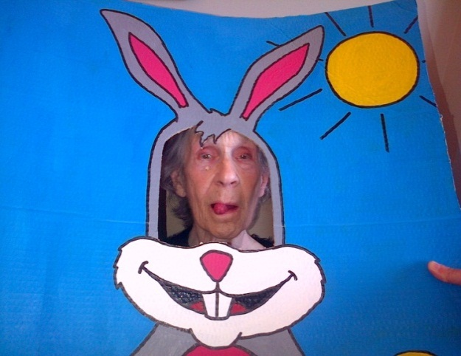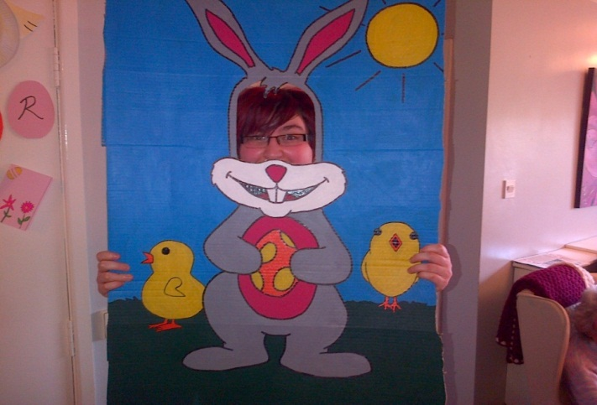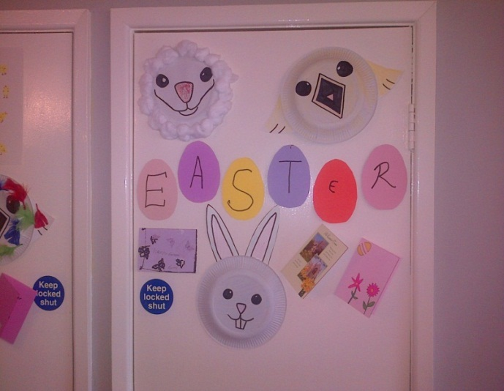

We also raised £244.40 from our giant Easter egg raffle and car boot sale, and everyone from Bryn Derwen would like to sincerely thank the family of the late Mr Donald Floyd for kindly donating the raffle prize, as well as everyone who donated items to be sold in our car boot sale.

**St George’s Day**

As part of our St George’s Day celebrations we spent the morning listening to music whilst we worked on our flag collages in our arts and crafts session.

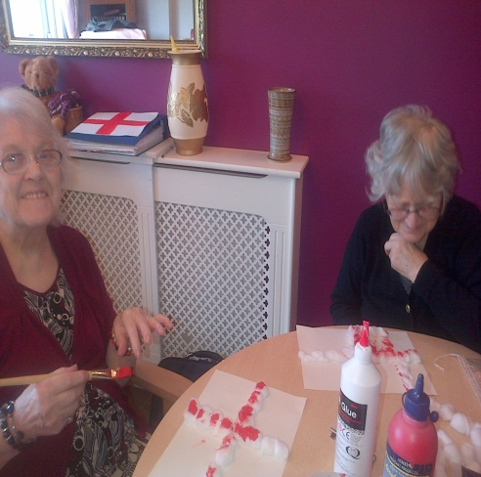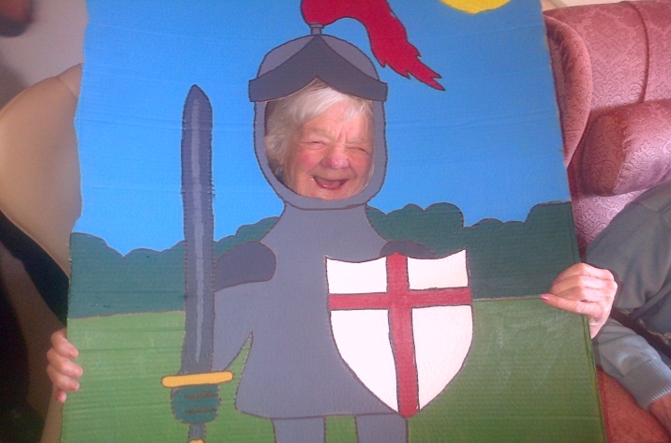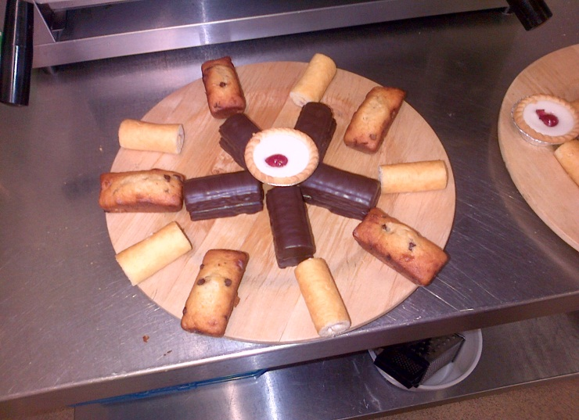

After having our photographs taken with our themed character board, the residents were then treated to an afternoon English tea party where tea, coffee and a large selection of delicious cakes were provided for everyone to enjoy.

**Forthcoming Events**

The following are a list of dates that our weekly entertainment will be visiting and also dates for our organised parties. We would like to invite you all to come and join in with us on these special occasions

Entertainers

* Wednesday 14/5/14 @ 10.30-12.00
* Wednesday 28/5/14 @ 10.30-12.00
* Wednesday 11/6/14 @ 10.30-12.00
* Wednesday 25/6/14 @ 10.30-12.00
* Wednesday 09/7/14 @ 10.30-12.00
* Wednesday 23/7/14 @ 10.30-12.00
* Wednesday 06/8/14 @ 10.30-12.00
* Wednesday 20/8/14 @ 10.30-12.00

Parties

* **Father’s Day** Friday 13/6/14- we will be making cards and decorating our home in preparation for this important day
* **Summer Garden Party** Thursday 19/6/14- we have already started planning ways to make this year’s summer party even bigger and better than last years!

We are also pleased to inform you that we intend to organise special day trips out as the weather gets warmer so that we can have picnics together, as well as fish and chips at the seaside.

**Fundraising**

After only one year of running our various fundraising events, we are very pleased to announce that we have raised £802 in total for the resident’s fund. This money will go towards helping to provide our residents with day trips out, a variety of entertainment, and purchasing new items to use in our activities programme.

We would once again like to take this opportunity to thank you all for your continued help and support, and should anyone wish to play our lottery or take part in any of our other fundraising events then please could they speak to Helen Johnson (Activities Organiser) for further details.

**Other News**

**Coming soon**

As part of our continuing commitment to the Activities Programme, we are pleased to announce that Bryn Derwen will be investing in a Nostalgic Display Cabinet for use in our main lounge.

The retro items which will be included in this reminiscence display will all be in full working order and will help to trigger memories and promote conversation.

We will inform you when this project is completed and discuss it in further detail in our next newsletter.

**Congratulations**

We would like to take this opportunity to congratulate Ebony Archer on her recent promotion to Senior Carer. Ebony has worked here at Bryn Derwen for two years and we wish her well in her new role.

**Condolences**

The staff and residents of Bryn Derwen would like to express their deepest sympathies to the families of Mr Charles Williams, Mr Donald Floyd, and Mr John S Davies who sadly passed away this year.